Exercise 6
- Order all employees on the basis of the salary they draw.
SELECT l_name, f_name, salary from employee_data ORDER BY salary;
- List all employees in descending order of their year of service.
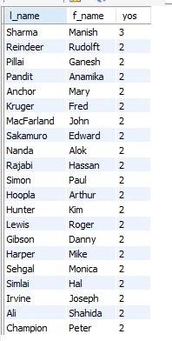
- What does the following statement display?
SELECT emp_id, l_name, title, age from employee_data ORDER BY title DESC, age ASC;
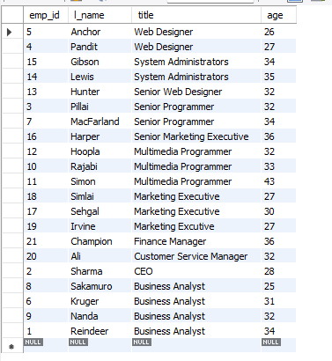
- Display employees (last names followed by first names) who hold the title of either “Programmer” or “Web Designer” and sort their last names alphabetically.
SELECT l_name, f_name, title from employee_data WHERE title = 'Senior Programmer' or title = 'Web Designer' ORDER BY l_name ASC;
